- Inside Morgue Setup, no need to keep this “Body Statuses” setup. Instead, after receiving the body from whether IPD Ward/Emergency, the body intake request will need an approval. From the approval layer, the body intake will go to the Cold Storage Request section, for cold storage assignment, if the next flow in “What happens next” is set as “Cold Storage”, otherwise the body status will go as “Immediate Release”.
- Further the release flow is same from the “In Cold Storage” and “Immediate Release” body status.

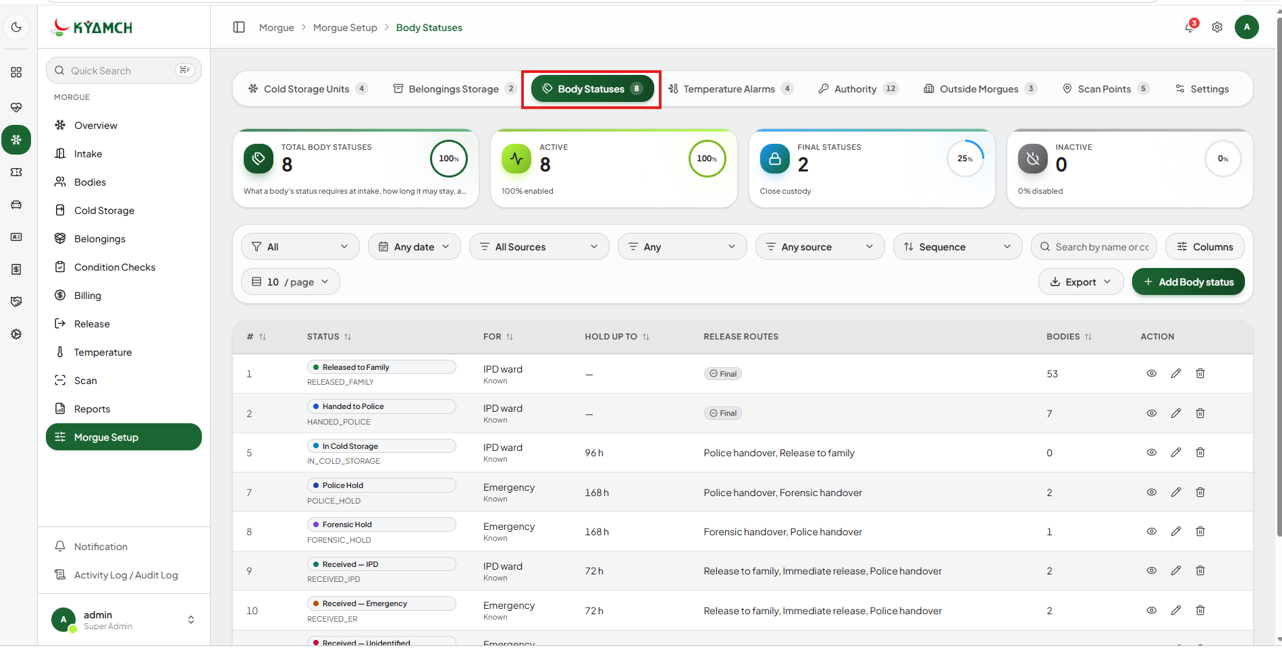
- For the release keep two routes only, “Release to Family”, and “Police/Forensic Handover”

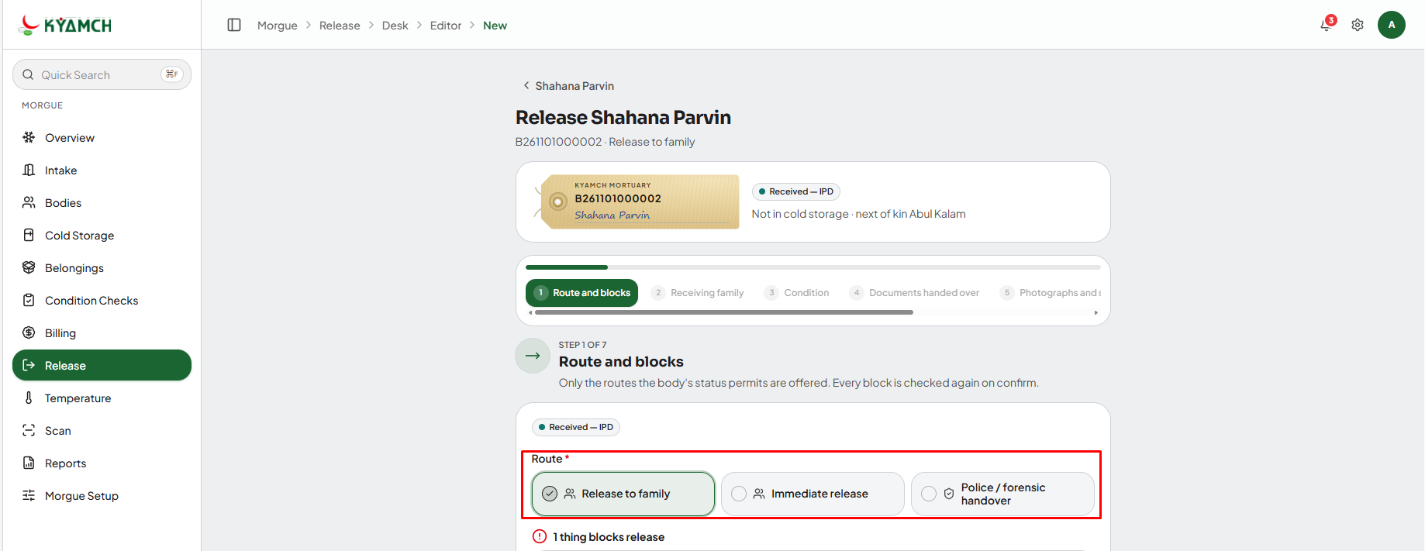

- In the “Intake” feature, bodies coming from the IPD Ward, must have an issued death certificate, and cleared billing clearance
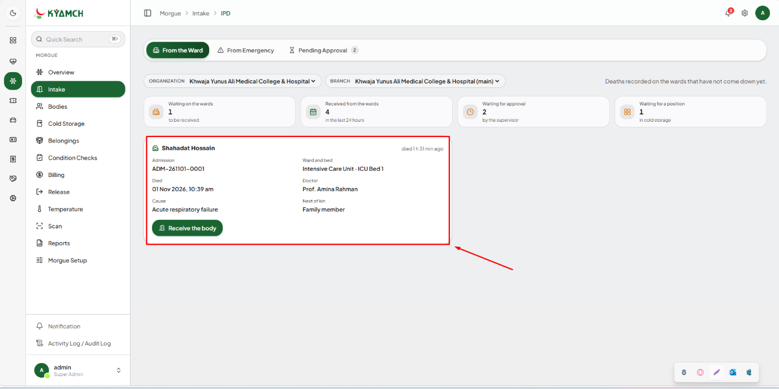

- The information in the marked fields given below, must come as auto-filled information

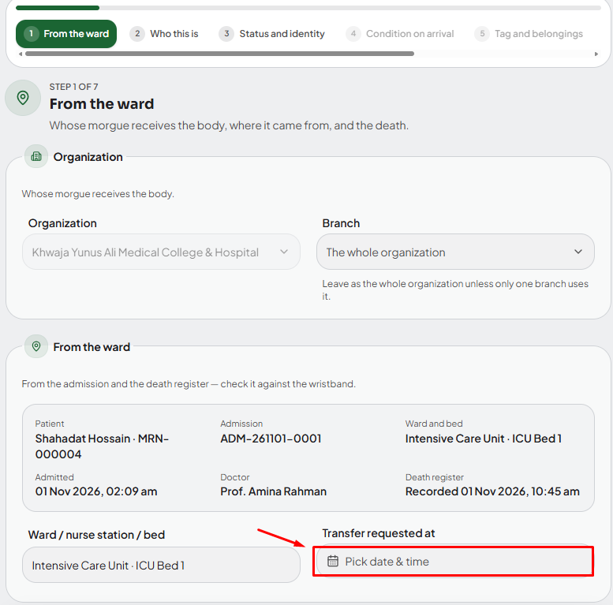

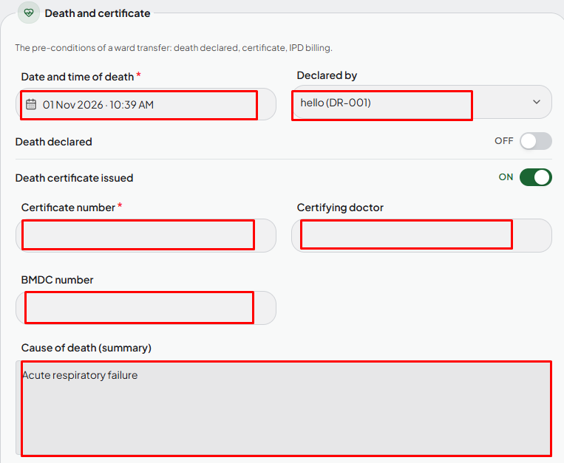

- Since the Death Declared patients are only bring in here no need to keep the checks for “Death Declared”, and “IPD billing Cleared”

- The patient information must auto-fill from the HIS Registration Number info

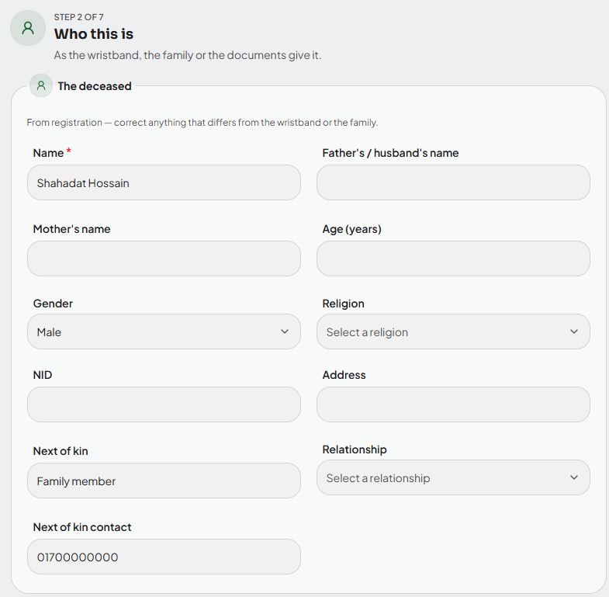

- The Body number must show here automatically, no need to type it here.
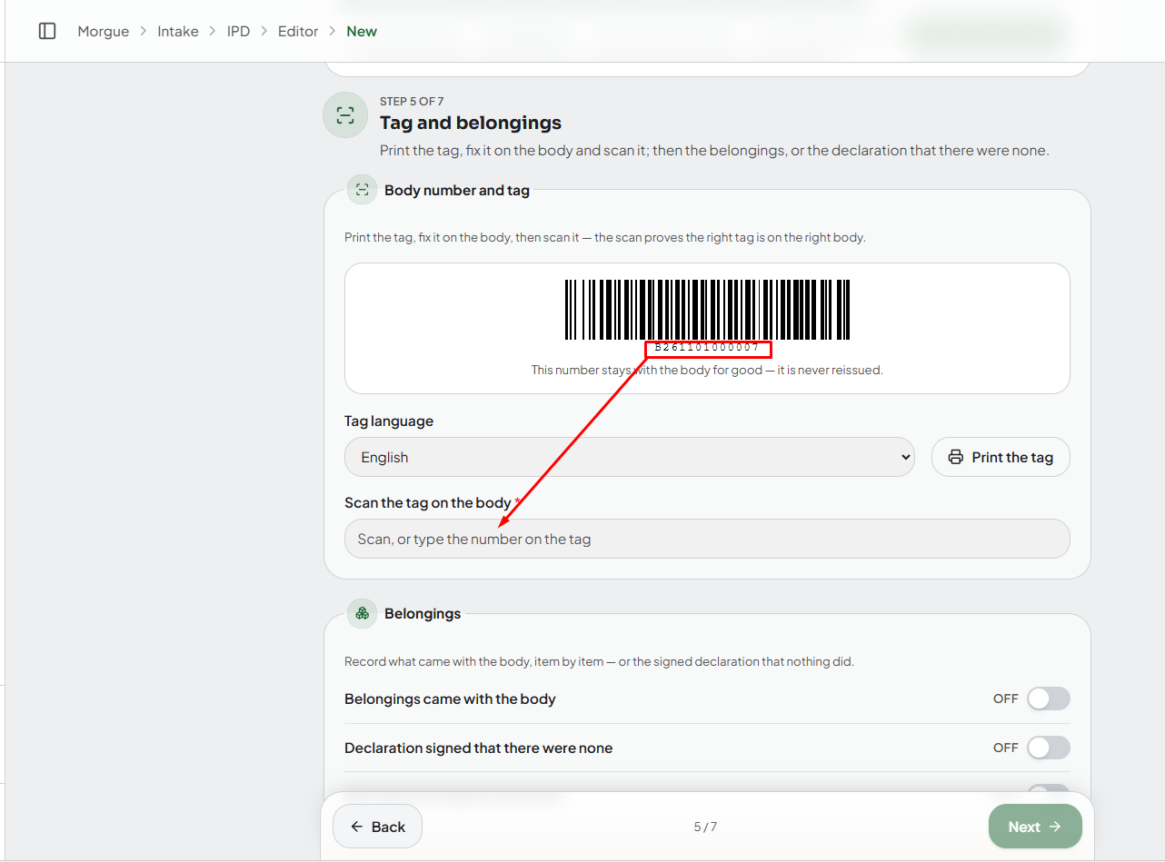

*** For the Emergency Intake keep 1-5 points same

